ASSIGNMENT 8

1.When to use (Rapid Application Development) RAD model When not to use (Rapid Application Development) RAD model

RAD is used if the customer wants the product within a short duration .In RAD we give more importance to quick development rather than quality of the product.also we can say that RAD should be used when there is a need to create a system that can be modularized in 2-3 months of time.RAD can be used only if the organization have domain experts and automated tools,these are required because we want to develop the software within short duration.because of these factors the project development became more expensive and complex.
RAD model is not used if the customer give enough time for the project team to complete the project.if we are giving more importance to quality then RAD cannot be used.we cannot use RAD for large or highly complex projects.

2.Define an ER diagram of a software Organization with all the relationship model that was discussed in the classroom

Department
Works
for
Works
on
Project
Id
Platform
Name
Client
Id
DOB
Phone
Address
Name
Request
for
Controls
Dept Id
Dept Name
1
Employee
Id
Age
DOB
DOB
Phone
Address
Name
First Name
Street
Location
Middle Name
Last Name
House
Name
Street
Location
N
N

3.Describe the Entity Relationships for the following diagram

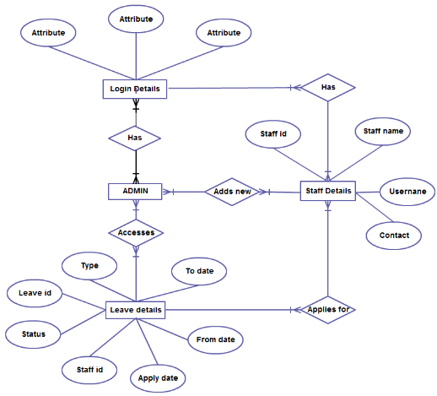

Description of the above displayed ER Diagram:

Entities:
There are mainly 4 entities here namely: Login Details, ADMIN, Leave Details and Staff Details.

Attributes of the entities:
- Login Details has 3 Attributes.
- Staff Details has Staff Id, Staff Name, Username and Contact.
- Leave Details has Leave Id, Type, To date, From date, Apply date, Staff Id and Status.

Relationships between the entities (The relationships are the ones highlighted):
- There are more than one ADMINs, as is obvious from the diagram. So each ADMIN Has a unique Login Details. (One to One)
- The ADMIN has access to the Staff’s details; i.e. one ADMIN Accesses one or many Leave Details. (One to Many)
- The ADMIN Adds new Staff Details; i.e. one ADMIN can add one or more Staff Details. (One to Many)
- The Staff can apply to one or more leaves; i.e. One or more Staff Details can Applies of one or more Leave Details. (Many to Many).
- Each Staff has a unique login detail; i.e, One Staff Has One Login Details. (One to One)

